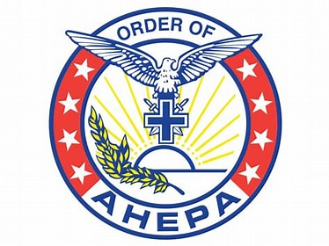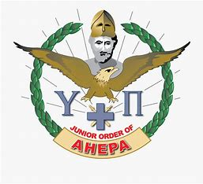

District #24 Scholarship Program
(Alberta, Saskatchewan, Manitoba)

The Order of AHEPA and Daughters of Penelope Joint Scholarship of $1500 is awarded to:
- a member of the AHEPA Family of District 24 or the children or grandchildren of a member in good standing of the AHEPA Family of District #24
- a student currently enrolled in a post graduate program. Undergraduate marks will be used to determine eligibility.
- a student enrolled in an undergraduate program at a post-secondary institution with a high school average of 80% or higher will be considered if there is no applicant in a post graduate program.

The William H. Girgulis Memorial Scholarship of $1500 is awarded to:
- a member in good standing of the Maids of Athena or Sons of Pericles in District #24
- a student enrolled in an undergraduate program at a post secondary institution
- a student with a high school average of 80% or higher.

Apostolos Marinakos Memorial Scholarship of $1500 is awarded to:
- a member of the AHEPA Family of District 24 or the children or grandchildren of a member in good standing of the D 24 AHEPA Family
- a student who has completed their first year and continuing in one of the S.T.E.A.M faculties (Science, Technology, Engineering, Arts or Math) at a post-secondary institution with a high school average of 80% or higher.

NOTE: 1. All scholarships are awarded at the annual District Convention.
2. Payment of scholarships will be made directly to the recipient.
3. Recipients are only eligible to win a scholarship once.
4. Unsuccessful candidates may reapply.

Scholarship Application Form

Full Name: ______________________________________________________________

Address: ______________________________________________________________

City: _______________ Province: __________Postal Code: ______________

Phone #: _______________ S.I.N. _____________ Email: _____________________

Post secondary institution you are attending ______________________________

Current Course of Study: _______________________ Year of Study__________

Official Department of Education high school transcripts are required.

NOTE: If you are in graduate school please provide:

Official undergraduate transcripts

Graduate institution you are attending _________________________________

Current Course of Study: _______________________________________________

For students in any of the STEAM programs please indicate what activities you are participating in that involve Research, Innovation and/or Involvement on teams or projects in your faculty.

_________________________________________________________________________________

_________________________________________________________________________________

NOTE: The marks used to determine the average will be the senior matriculation level academic subjects of Math, Social Studies, English, the highest Science mark and the highest of another academic subject.

Scholarship applications must be received at the address below no later than May 1

Official transcripts must be forwarded directly, by mail or electronically, to:
Vasilia (Celia) Kachmarski
26-72 Millside Drive SW
Calgary, AB T2Y 3G8
vkachmarski@shaw.ca

Verification of Membership

If you, your parents or grandparents are members of the AHEPA Family please complete the following:

Member’s Name: _____________________________________________________

Relation to applicant: _________________________________________________

Name of Chapter: __________________________ City: ____________________

Signatures: _____________________________ _____________________________
Chapter President Secretary (verifies standing)

_____________________________ _______________________
Applicant’s Name Date

If you are a member in good standing of the Sons of Pericles or Maids of Athena please complete the following:

Name of Chapter: _____________________ City: ______________________

Signatures: ____________________________ ___________________________
Chapter President Secretary (verifies standing)

___________________________ ___________________________
Applicant’s signature Date

Deadline for applying is May 1

Reviewed/updated June 2025

